Project Design Phase-II
Data Flow Diagram & User Stories

Date | 30 August 2026
Team ID
Project Name | An employee requests installation of licensed software through the Service Catalog
Maximum Marks | 4 Marks

Data Flow Diagrams:
A Data Flow Diagram (DFD) is a traditional visual representation of the information flows within a system. A neat and clear DFD can depict the right amount of the system requirement graphically. It shows how data enters and leaves the system, what changes the information, and where data is stored.

Level 0 (Context Diagram):
- External Entities: Employee (End User), IT Fulfiller (Software Support), System Administrator.
- Process: 0.0 Software Installation Request System
- Data Flows: Employee submits Software Details -> System returns Order Confirmation & Status updates. Fulfiller updates Task State (sc_task) -> System triggers Incident logging on hold.
Level 1 (Detailed Process Flow):
- Process 1.0 (Submit Request): User submits request via Service Catalog -> Saves into sc_req_item & sc_request Data Stores.
- Process 2.0 (Flow Designer Engine): System triggers approval & generates Catalog Task (sc_task) assigned to Software Support.
- Process 3.0 (Fulfillment & Exception Rule): Fulfiller updates task state. If State = On Hold (3), Business Rule automatically reads sc_req_item variables and inserts a record into the incident Data Store.

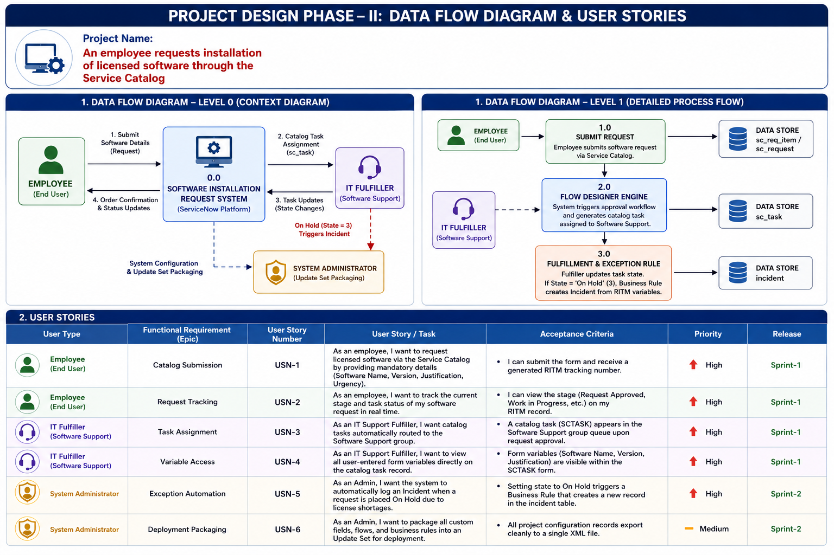
User Stories

User Type | Functional Requirement (Epic) | User Story Number | User Story / Task | Acceptance Criteria | Priority | Release
Employee (End User) | Catalog Submission | USN-1 | As an employee, I want to request licensed software via the Service Catalog by providing mandatory details (Software Name, Version, Justification, Urgency). | I can submit the form and receive a generated RITM tracking number. | High | Sprint-1
Employee (End User) | Request Tracking | USN-2 | As an employee, I want to track the current stage and task status of my software request in real time. | I can view the stage (Request Approved, Work in Progress, etc.) on my RITM record. | High | Sprint-1
IT Fulfiller | Task Assignment | USN-3 | As an IT Support Fulfiller, I want catalog tasks automatically routed to the Software Support group. | A catalog task (SCTASK) appears in the Software Support group queue upon request approval. | High | Sprint-1
IT Fulfiller | Variable Access | USN-4 | As an IT Support Fulfiller, I want to view all user-entered form variables directly on the catalog task record. | Form variables (Software Name, Version, Justification) are visible within the SCTASK form. | High | Sprint-1
Customer Care Executive | Support & Triage | USN-5 | As a Customer Care Executive, I want visibility into software request statuses so I can update employees when they query about fulfillment delays. | I can access and search sc_req_item records by employee name or RITM number. | Medium | Sprint-1
System Administrator | Exception Automation | USN-6 | As an Admin, I want the system to automatically log an Incident when a request is placed On Hold due to license shortages. | Setting state to On Hold triggers a Business Rule that creates a new record in the incident table. | High | Sprint-2
System Administrator | Deployment Packaging | USN-7 | As an Admin, I want to package all custom fields, flows, and business rules into an Update Set for deployment. | All project configuration records export cleanly to a single XML file. | Medium | Sprint-2

